Comoros

## Political Stability Estimate Data

The data set shows the political stability estimate of the country each year.

## # A tibble: 19 x 5  
## country iso3c date stability stabilityCategory4   
## <chr> <chr> <dbl> <dbl> <chr>   
## 1 Comoros COM 1996 0.507 moderately stable   
## 2 Comoros COM 1998 0.564 moderately stable   
## 3 Comoros COM 2000 0.0219 moderately stable   
## 4 Comoros COM 2002 0.403 moderately stable   
## 5 Comoros COM 2003 -0.673 moderately unstable  
## 6 Comoros COM 2004 -0.163 moderately unstable  
## 7 Comoros COM 2005 -0.435 moderately unstable  
## 8 Comoros COM 2006 -0.360 moderately unstable  
## 9 Comoros COM 2007 -1.09 highly unstable   
## 10 Comoros COM 2008 -1.11 highly unstable   
## 11 Comoros COM 2009 -0.767 moderately unstable  
## 12 Comoros COM 2010 -0.563 moderately unstable  
## 13 Comoros COM 2011 -0.553 moderately unstable  
## 14 Comoros COM 2012 -0.452 moderately unstable  
## 15 Comoros COM 2013 -0.257 moderately unstable  
## 16 Comoros COM 2014 -0.187 moderately unstable  
## 17 Comoros COM 2015 -0.233 moderately unstable  
## 18 Comoros COM 2016 0.0358 moderately stable   
## 19 Comoros COM 2017 0.0307 moderately stable

## Political Stability Estimate Plot

The plot shows the trends of stabilization and destabilization for the each country.

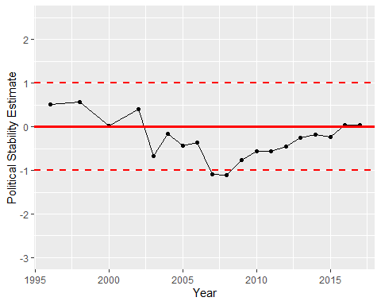

Political Stability Trend